Parth Babbar

Blockchain and Cryptocurrency in Banking

Introduction:
Blockchain technology and cryptocurrencies are altering the financial environment by providing new ways to perform transactions, save data, and assure security. Their implementation in the banking sector of the United States is rapidly expanding. Blockchain's decentralized ledger assures data security and integrity, whereas cryptocurrencies rely on cryptographic techniques to safeguard transactions and regulate new units. This study examines their uses, benefits, difficulties, and prospective solutions in US banking, accompanied by pertinent statistics.
Application of Blockchain:
- Payments and Settlements: Blockchain technology simplifies the payment and settlement process by creating a transparent and immutable ledger that eliminates the need for middlemen. This results in speedier transactions and lower expenses.
- Fraud Reduction: Blockchain's immutable ledger makes it practically difficult to change transaction records, dramatically lowering the risk of fraud.
- Know Your client (KYC): Blockchain can make the KYC process easier by providing a single, immutable version of client data that banks can securely communicate, decreasing redundancy and increasing data integrity.
- Trade Finance: Blockchain can digitize trade documentation and automate the trade finance process, increasing efficiency and lowering the risk of fraud.
- Loan and Credit score: Blockchain-based smart contracts may automate loan negotiations, and the immutable ledger can improve credit score accuracy and transparency.
Application of Cryptocurrency:
- Digital Payments: Cryptocurrencies such as Bitcoin and stablecoins provide quicker and cheaper transactions than traditional banking systems.
- Cross-Border Transactions: Cryptocurrencies can help with cross-border transactions by removing the requirement for currency translation and lowering transaction fees and timeframes.
- Investment options: Cryptocurrencies provide new investment options for clients as well as new revenue streams for banks through custodial services, trading platforms, and investment products.
- ICO Fundraising: Initial Coin Offerings (ICOs) are a new approach for firms to obtain funds, with banks potentially acting as consultants or underwriters.
Benefits:
- Enhanced Transparency: The blockchain's transparent ledger ensures that all parties have access to the same data, which improves confidence and accountability in financial transactions.
- Cost-Effectiveness: By eliminating intermediaries and simplifying operations, blockchain and cryptocurrencies may drastically reduce operating expenses for banks.
- Enhanced Security: The decentralized structure of blockchains and its cryptographic security lower the danger of data breaches and fraud, hence improving overall security.
- Increased Efficiency: Automating activities with smart contracts and blockchain may shorten processing times, decrease mistakes, and increase the efficiency of banking operations.
- Financial Inclusion: Cryptocurrencies can provide financial services to the unbanked and underbanked, creating new avenues for inclusion in the financial system.
- Faster Transactions: Unlike traditional banking systems, which can take days to settle, blockchain allows for near-instantaneous transactions.
- Decentralization: Blockchain's decentralized nature eliminates reliance on central authority, resulting in a more resilient and robust financial system.
Challenges:
- Regulatory ambiguity: The regulatory landscape for blockchain and cryptocurrencies is constantly growing, creating ambiguity and potential legal difficulties for banks.
- Security Concerns: Although blockchain is safe, it is vulnerable to assaults, particularly at the application layer. Large-scale hacking have also targeted cryptocurrency exchanges and wallets.
- Scalability challenges: Blockchain networks may experience scalability challenges, resulting in longer transaction times and higher fees during periods of strong demand.
- Integration with Legacy Systems: Integrating blockchain into current financial systems may be difficult and expensive, necessitating considerable modifications to infrastructure and operations.
- Consumer Trust and knowledge: Many customers still lack trust and knowledge of blockchain and bitcoin, preventing mainstream adoption.
Solutions:
- Clear Regulatory Framework: To decrease uncertainty and promote innovation, governments and regulatory agencies must set clear standards and frameworks for the use of blockchain and cryptocurrencies in banking.
- Enhanced Security: To secure blockchain and cryptocurrency assets, banks must invest in sophisticated security measures such as multi-factor authentication, encryption, and continuous monitoring.
- Scalability Solutions: Developing and implementing solutions like as sharding, layer 2 protocols, and novel consensus methods can assist solve scalability concerns.
- Seamless Integration: Banks should take a staged approach to integrating blockchain, beginning with pilot projects and progressively expanding as technology and procedures evolve.
- Education and Awareness: Banks should invest in consumer education and awareness initiatives to foster trust and knowledge of blockchain and cryptocurrency technology.
Statistics:
- As of 2023, more than 90% of US banks are studying blockchain technology, with over 40% having already used it in some form.
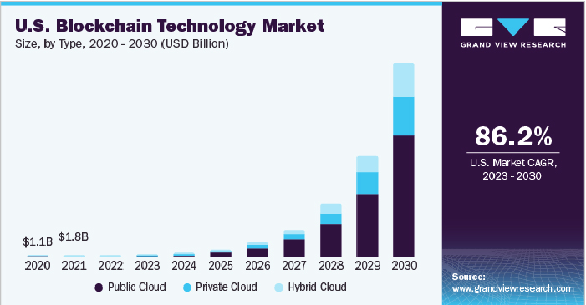
- Blockchain technology can shorten transaction settlement times from days to minutes, with typical cross-border transaction times cut by 40-60%.
- Banks may save up to $20 billion per year by 2025 by implementing blockchain in cross-border payments, securities trading, and regulatory compliance.
- Approximately 21 million Americans (8% of the population) possess cryptocurrencies, with considerable growth seen in Bitcoin and Ethereum ownership.
Conclusion:
Blockchain and cryptocurrencies have the potential to alter the US banking system by increasing efficiency, lowering costs, and opening up new options. To fully enjoy these benefits, banks must overcome regulatory uncertainty, handle security and scalability issues, and build customer trust and comprehension. Blockchain and cryptocurrency have the potential to play a significant role in the future of US banking if the correct tactics and solutions are implemented.

